Denis LePage and HighBanks

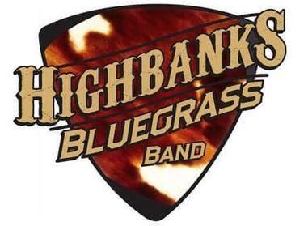HighBanks is multi-award winning banjoist, Denis LePage’s latest bluegrass band collaboration. In late 2019 when the bluegrass band that he had been playing with for 5 years decided to fold, he wanted to continue performing and arranged to assemble an outstanding group of bluegrass instrumentalists and vocalists that would become

**The HighBanks Bluegrass Band.**

The summer bluegrass festival season of 2022 was a busy one for HighBanks and saw them headlining and performing at numerous festivals including the long running bluegrass festivals at Tottenham, Palmer Rapids, River Valley and many more. In addition, in the spring, fall and winter months of 2022, the band played shows at fairs and clubs including the Simcoe County Fair, Norfolk’s Cornstalk Festival, the Moonshine Café, The Front Porch Southern Kitchen, The West Niagara Agricultural Fair, The Hometown Hideaway and more.

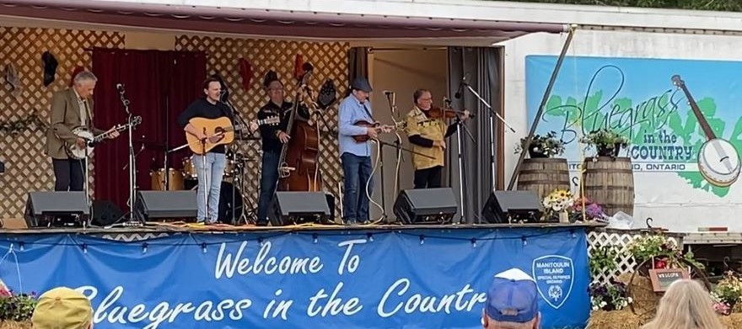The bluegrass festival season of 2023 continued on the same trend with HighBanks returning to almost every bluegrass festival that the band had played in 2022 as well as receiving invitations to headline at the Coombs Bluegrass Festival on Vancouver Island and Bluegrass in the Country on Manitoulin Island.

HighBanks is currently working on their first full length album and expects it to be ready for streaming by the summer of 2024.

Samples of HighBanks’ live shows can be found on the music page of their website at

<https://www.thehighbanksband.com/music.php>

Contact Information:

Denis LePage

13043 Lakeshore Rd.

Wainfleet, ON L0S 1V0

Phone: 905 933 0541

Email: [dlepage99@gmail.com](mailto:dlepage99@gmail.com)

Band Members

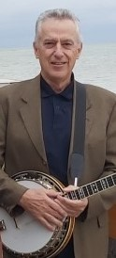**Denis LePage**

Denis is well known in Canadian bluegrass circles as a founding member of London Ontario’s Dixie Flyers. As a member of that group, he recorded several albums for Boot Records including the bands inaugural album. The ‘Flyers’ were arguably the most well known bluegrass band in the area at the time and were invited to play some of the most important bluegrass shows including the Carlisle Bluegrass Festivals and Bill Monroe’s Bean Blossom Bluegrass Festival.

Having spent 6 years with the Dixie Flyers, Denis joined Station Road. Denis LePage and Station Road continued with an active performing schedule for 5 years and also performed at many well-known bluegrass and folk festivals including Carlisle, the Winfield Kansas Guitar Competition and the Winnipeg Folk Festival. They released three albums for Boot, two of which were recorded in Hamilton Ontario and one record in Nashville Tennessee.

Limited Edition was Denis’ next musical venture and this was a band that also kept a busy performing schedule including again performing at many bluegrass and folk festivals including the Renfrew Festival, and the Winnipeg, Vancouver and Northern Lights Folk Festivals. In the late ‘80’s the group toured with and backed up the late Mac Wiseman. The group released one album on its own label.

Denis has won the Central Canada Bluegrass Awards’ Banjo Player of the Year 4 times, is a much sought after banjo instructor and session musician and has held or chaired many banjo workshops. He has released 2 solo banjo albums. In addition he is the winner of the Carlisle banjo competition. He has had the opportunity in the past to perform or share the stage with many other banjo and bluegrass greats including Alan Munde, Tony Trishka, John Hickman, Byron Berline, Dan Crary and more.

As well as keeping a busy performing schedule, Denis is a director on the Bluegrass Music Association of Canada (BMAC) Board of Directors, is the organization’s webmaster and is a regular contributor to BMAC’s quarterly magazine.

# Eric Brousseau

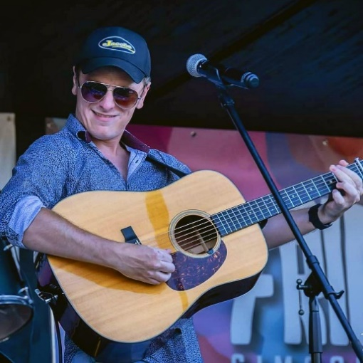Coming from a family steeped in music, Eric has a profound knowledge of both traditional bluegrass and newer influences. He is one of the Canada's best guitar instrumentalists as well as being a fantastic vocalist with a welcoming and energetic stage presence at live shows.

During his career, Eric has performed as a soloist, and in groups and is always in great demand. In addition to his traditional bluegrass music repertoire, his contemporary influences add a special blend to all of HighBanks' shows.

# Maurice (Moe) Juteau

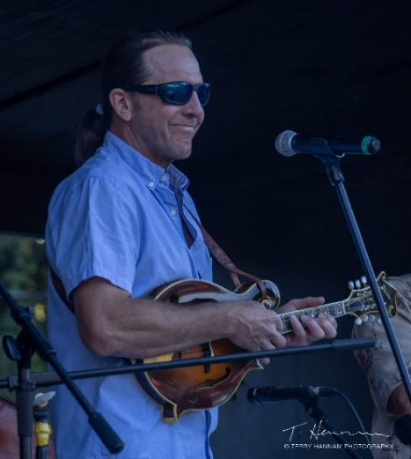Moe’s long career in bluegrass music kicked into gear when he joined Hamilton, Ontario’s well-known group, The East Mountain Boys. He met the other band members at one of the now legendary Bluegrass Canada Festivals in the early 80’s. He started his mandolin playing with that band and has now become a true virtuoso on the instrument drawing cheers and accolades from audiences when he steps forward to take a solo!  
Since his early days, Moe has been part of several bands and has performed at countless festivals and shows. He is a prolific song writer, and accomplished guitar and harmonica player. His original songs, unique vocals and easy stage presence are a huge contribution to HighBanks

# Jim Young

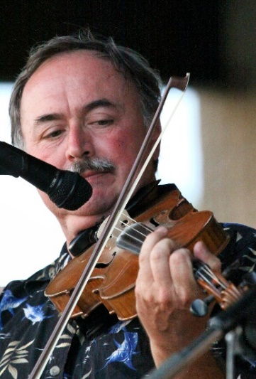Hearing Jim Young on the violin is a rare treat you won’t soon forget. He hails from a country music background and can make his fiddle fill your heart with sadness, joy and happiness - he is a true virtuoso. Jim came from a musical family on both sides. His father played guitar in local Country bands, his uncle was a fiddler and his grandfather was a square dance caller. Jim started playing guitar when he was 8 years old, chording to square dance and fiddle tunes at family house parties.

When he was in junior high school, he was introduced to violin playing by a local high school teacher who came into his music classes and eventually studied violin at the Bradley Institute in Niagara Falls throughout his high school years. Although classically trained, he never lost his love for country music and fiddle tunes. He has toured Canada for many years, playing and singing with top Canadian country entertainers. Now Jim has returned to his roots in bluegrass music with his outstanding fiddle playing and vocals for HighBanks.

# Glenn George

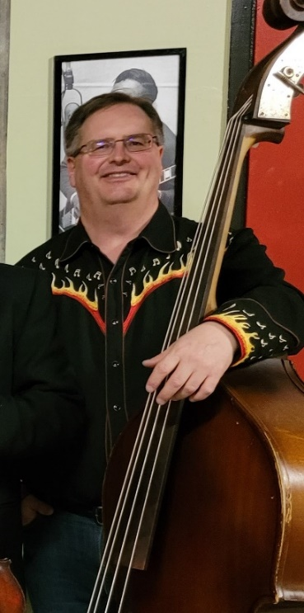Holding down the low end is bass player, Glenn George. Originally from Kitchener, Ontario, Glenn now lives in the village of Alma with his wife Norma. Glenn has been playing bluegrass bass for nearly 40 years. He is the founder of the Waterloo Wellington Bluegrass Music Association and currently holds the position of Workshop Coordinator.

Glenn has played in many bluegrass ensembles throughout his tenure, notably with Clean Sweep, Foxtail and the Barn Katz. He has been twice nominated as Bluegrass Bassist of the Year by the Central Canadian Bluegrass Awards. You will enjoy his contributions both on bass and vocally to The Highbanks Bluegrass Band sound.